📘 Online Learning Management System (LMS)
Team Number: Team 1
Project Type: Academic Major Project

1️⃣ Cover Page
Project Title:
Online Learning Management System (LMS)
Team Number: Team 1
Project Description:
An Online Learning Management System designed to provide a centralized, scalable, and user-friendly platform for digital education, enabling administrators, instructors, and students to interact efficiently.
Technologies Used:
- Frontend: HTML, CSS, JavaScript, Bootstrap
- Backend: Python
- Database: NoSQL / SQLite
- Tools: VS Code, Web Browser

2️⃣ Background / Problem Statement
Evolution of E-Learning
Education has evolved from traditional classroom-based learning to digital and hybrid models. With the advancement of internet technologies, online learning platforms have become essential for delivering education to a global audience.
Problems with Traditional Classroom Systems
Traditional education systems rely heavily on physical presence, fixed schedules, and manual processes. These systems face limitations such as:
- Limited reach to students in remote areas
- Fixed learning schedules
- Difficulty in tracking student performance efficiently
Limitations of Existing Manual / Partial Digital Systems
Many institutions still depend on partially digital systems where:
- Course materials are scattered across platforms
- Attendance and assessments are manually managed
- Communication between students and instructors is inefficient
Real-World Challenges
- Scalability: Difficulty handling a large number of students
- Accessibility: Learning restricted by time and location
- Performance Tracking: Manual evaluation leads to inaccuracies
- Content Management: No centralized repository for learning materials
- Communication Gaps: Lack of real-time interaction and feedback
Hence, there is a strong need for a comprehensive Online Learning Management System.

3️⃣ Objectives of the System
The primary objectives of the Online Learning Management System are:
- To provide a centralized learning platform
- To enable anytime, anywhere access to learning resources
- To support role-based access (Admin, Instructor, Student)
- To monitor and evaluate student performance effectively
- To ensure a secure, scalable, and efficient system

4️⃣ System Architecture
DAIGRAM
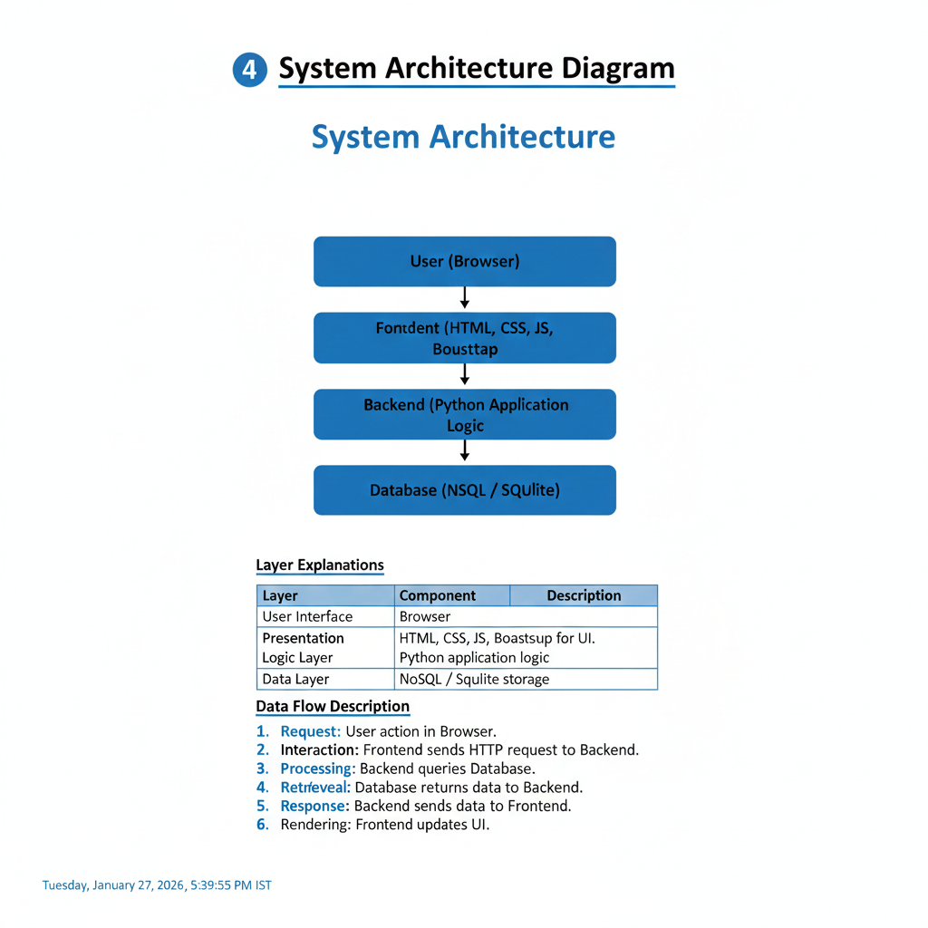
Architecture Overview
User (Browser)
|
Frontend (HTML, CSS, JavaScript, Bootstrap)
|
Backend (Python Application Logic)
|
Database (NoSQL / SQLite)
Explanation of Layers
- User Layer:
Users interact with the system through a web browser.
- Frontend Layer:
Provides a responsive and user-friendly interface using HTML, CSS, JavaScript, and Bootstrap.
- Backend Layer:
Handles application logic, authentication, data processing, and communication between frontend and database.
- Database Layer:
Stores user data, course content, assessments, and results securely.
Data Flow
User requests → Frontend → Backend → Database → Backend → Frontend → User

5️⃣ Module Description
🔹 Admin Module
- User registration and role assignment
- Course approval and management
- Monitoring system usage
- Generating analytics and reports
- System configuration and maintenance
🔹 Instructor Module
- Course creation and updates
- Uploading videos, documents, and resources
- Creating quizzes and assignments
- Monitoring student progress and performance
- Providing feedback and grades
🔹 Student Module
- Registration and secure login
- Course browsing and enrollment
- Access to learning materials
- Participation in quizzes and assignments
- Viewing performance reports and feedback

6️⃣ Workflow Diagram
DAIGRAM
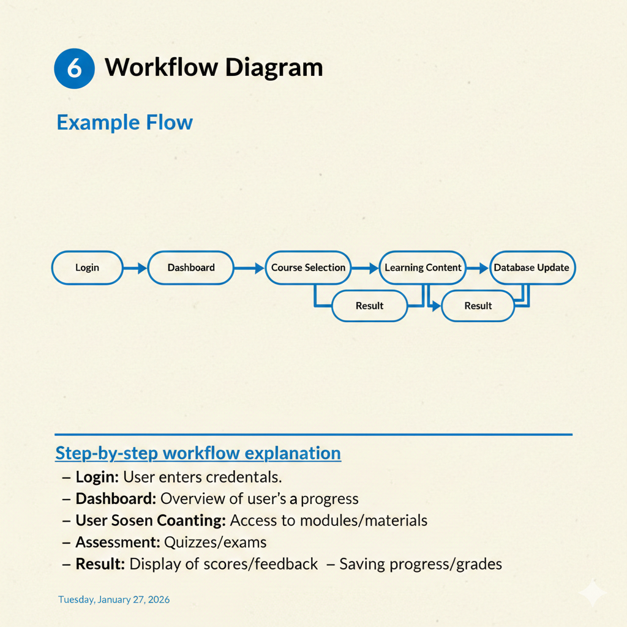
Workflow Process
Login → Dashboard → Course Selection → Learning Content
→ Assessment → Result → Database Update
Step-by-Step Explanation
- User logs into the system
- Dashboard displays available options
- Student selects a course
- Learning materials are accessed
- Assessments are attempted
- Results are generated
- Data is stored in the database

7️⃣ Project Life Cycle
The project follows the Agile Methodology:
- Requirement Gathering
- System Design
- Development (Sprint-based)
- Testing
- Deployment
- Maintenance
Agile enables continuous improvement and faster delivery.

8️⃣ System Requirements
Hardware Requirements
- Laptop / Desktop Computer
- Minimum 8 GB RAM
- Stable Internet Connection
Software Requirements
- Frontend: HTML, CSS, JavaScript, Bootstrap
- Backend: Python
- Database: NoSQL / SQLite
- Tools: VS Code, Browser

9️⃣ Advantages
- Flexible learning environment
- Cost-effective solution
- Scalable for large user base
- Real-time analytics and reports
- Improved student engagement

🔟 Limitations
- Requires internet connectivity
- Initial setup effort
- Data security and privacy concerns

1️⃣1️⃣ Applications
- Schools and colleges
- Corporate training platforms
- Online certification programs
- Coaching institutes

